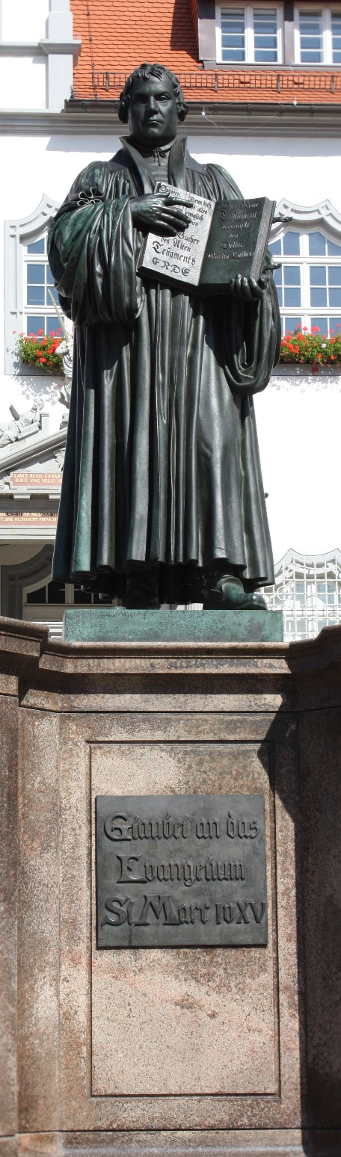
Reformation Festival
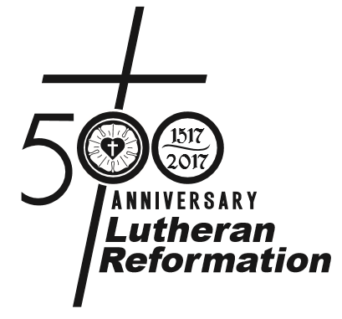
2016

Faith Lutheran Church
Markesan, Wisconsin

Sunday, October 30, 2016 3:00 p.m.

Opening Hymn Consider Now What God Has Done | by Judith Snell
(Tune: Lasst uns erfreuen TLH 15)
Please stand.

C: ♫ Consider now what God has done;
How His right hand the vic’try won;
He has conquered, In the battles!
Whether by many or by few,
Preserved His Word as none can do –
For salvation; Of all people!
Alleluia! Alleluia! Alleluia!

For through God’s grace and grace alone;
Faultless we stand before God’s throne.
Alleluia! What a Savior!
Our Substitute the ransom paid;
For all sins full atonement made.
Alleluia! Praise our Savior!
Alleluia! Alleluia! Alleluia!

O Holy Spirit, burning bright
Disperse all gloom, all error’s blight;
In the whole world – For all ages.
The Church’s Strength, her faithful Guide
Her ev’ry need by You supplied,
How we praise You, For Your blessing
Of protecting – All the Gospel! Alleluia!

Preserve for all Your wondrous Word;
Fully revealed in Christ, our Lord.
What a blessing! Now, forever!
This heritage of priceless worth;
Water of life for all the earth.
Guard it always – Is our prayer.
Alleluia! Alleluia! Alleluia!

INVOCATION

P: In the name of the Father, and of the Son, and of the Holy Spirit.
C: ♫ Amen.

Please be seated.

CHILDREN’S CHOIR Praise to You, the Church’s Lord | by Katherine Kutz
(Tune: Hendon, WS 786)

Praise to You, the Church’s Lord, For Your truth to us restored;
For this threefold cornerstone: Scripture, grace and faith alone,
Scripture, grace, and faith alone.

For Your grace, unearned and free, Loving, seeking, pard’ning me,
Giving me in heav’n a place – I am saved alone by grace.
I am saved alone by grace.

For my faith, Your gift divine; Not through any works of mine
Do I dare approach Your throne – I am saved by faith alone.
I am saved by faith alone.

For the Scriptures, wholly true, Guide for all I believe and do,
Means by which Your will is known – I will trust Your Word alone.
I will trust Your Word alone.

The congregation is invited to join in singing stanza 5:

C: ♫ May my heart within me burn, Never from these truths to turn.
May I guard them all my days. May I give You thanks and praise.
May I give You thanks and praise.

Saved by Grace Alone Pastor [insert pastor name]

…for all have sinned and fall short of the glory of God, being justified freely by His grace through the redemption that is in Christ Jesus.
~Romans 3:23-24

HYMN By Grace I’m Saved | TLH 373

C: ♫ By grace I’m saved, grace free and boundless;
My soul, believe and doubt it not.
Why waver at this word of promise?
Has Scripture ever falsehood taught?
So then this word must true remain:
By grace you, too, shall heav’n obtain.

By grace God’s Son, our only Savior,
Came down to earth to bear our sin.
Was it because of your own merit
That Jesus died your soul to win?
No, it was grace, and grace alone,
That brought Him from His heav’nly throne.

By grace! Oh, mark this word of promise
When you are by your sins oppressed,
When Satan plagues your troubled conscience,
And when your heart is seeking rest.
What reason cannot comprehend
God by His grace to you did send.

Saved by Faith Alone Pastor [insert pastor name]

Therefore we conclude that a man is justified by faith apart from the deeds of the law.
~Romans 3:28

Adult Choir By Faith | by Keith & Kristyn Getty and Stuart Townend

Saved by Scripture Alone Pastor [insert pastor name]

For I am not ashamed of the gospel of Christ, for it is the power of God to salvation for everyone who believes . . .
~Romans 1:16a

HYMN A Mighty Fortress Is Our God | TLH 262

C: ♫ A mighty Fortress is our God, A trusty Shield and Weapon;
He helps us free from ev’ry need That hath us now o’ertaken.
The old evil Foe Now means deadly woe;
Deep guile and great might Are his dread arms in fight;
On earth is not his equal.

With might of ours can naught be done, Soon were our loss effected;
But for us fights the Valiant One, Whom God Himself elected.
Ask ye, “Who is this?” Jesus Christ it is,
Of Sabaoth Lord, And there’s none other God;
He holds the field forever.

Tho’ devils all the world should fill, All eager to devour us,
We tremble not, we fear no ill, They shall not overpow’r us.
This world’s prince may still Scowl fierce as he will,
He can harm us none, He’s judged; the deed is done;
One little word can fell him.

The Word they still shall let remain Nor any thanks have for it;
He’s by our side upon the plain With His good gifts and Spirit.
And take they our life, Goods, fame, child, and wife,
Let these all be gone, They yet have nothing won;
The kingdom ours remaineth.

OFFERING

RESPONSIVE PRAYER FOR REFORMATION

P: For sending your Son to rescue the human race from sin,
C: We thank and praise You, O Lord.

P: For sending your Spirit to lead us to repentance and faith in Jesus as our Savior,
C: We thank and praise You, O Lord.

P: For teaching us that our righteous acts are filthy rags,
C: We thank and praise You all the more, O Lord, for the gift of Jesus’ righteousness.

P: For guiding Martin Luther to understand the scriptural truth, “The just shall live by faith,”
C: We thank and praise You, O Lord.

P: For blessing the spread of the pure gospel through the Lutheran Reformation during these last 500 years.
C: We thank and praise You, O Lord.

P: For keeping our Church of the Lutheran Confession faithful in proclaiming Your Word to this day,
C: We thank and praise You, O Lord.

P: For loyalty to hold to Your truth and remain Your true disciples,
C: We ask for the power of Your Spirit, O Lord.

P: For boldness to confess Your truth in a fallen world,
C: We ask for the power of Your Spirit, O Lord.

P: For zeal to spread the message of salvation in Christ alone,
C: We ask for the power of Your Spirit, O Lord.

P: With grateful hearts we raise our voices to proclaim,
C: “The just shall live by faith.” Amen.

THE LORD’S PRAYER Sung to the tune of Abide With Me (TLH 552)

C: ♫ Father in heaven, holy be Your name.
Your kingdom come. Your will be done the same
On earth as it is done in heav’n above.
Our Father, bless Your children with Your love.

Our daily bread provide for us each day.
As we forgive, so take our sins away.
In time of trial, saving Lord, be near,
From every evil our Deliverer.

Yours is the kingdom; over all things reign.
Yours is the power; all things You maintain.
Yours is the glory, sound it forth again.
For ever and for evermore. Amen!

BENEDICTION

P: The Lord bless you and keep you.
The Lord make His face shine upon you and be gracious unto you.
The Lord lift up His countenance upon you and give you peace.

C: ♫ Amen. Amen. Amen.

HYMN We Praise You and Acknowledge You, O God | LSB 941
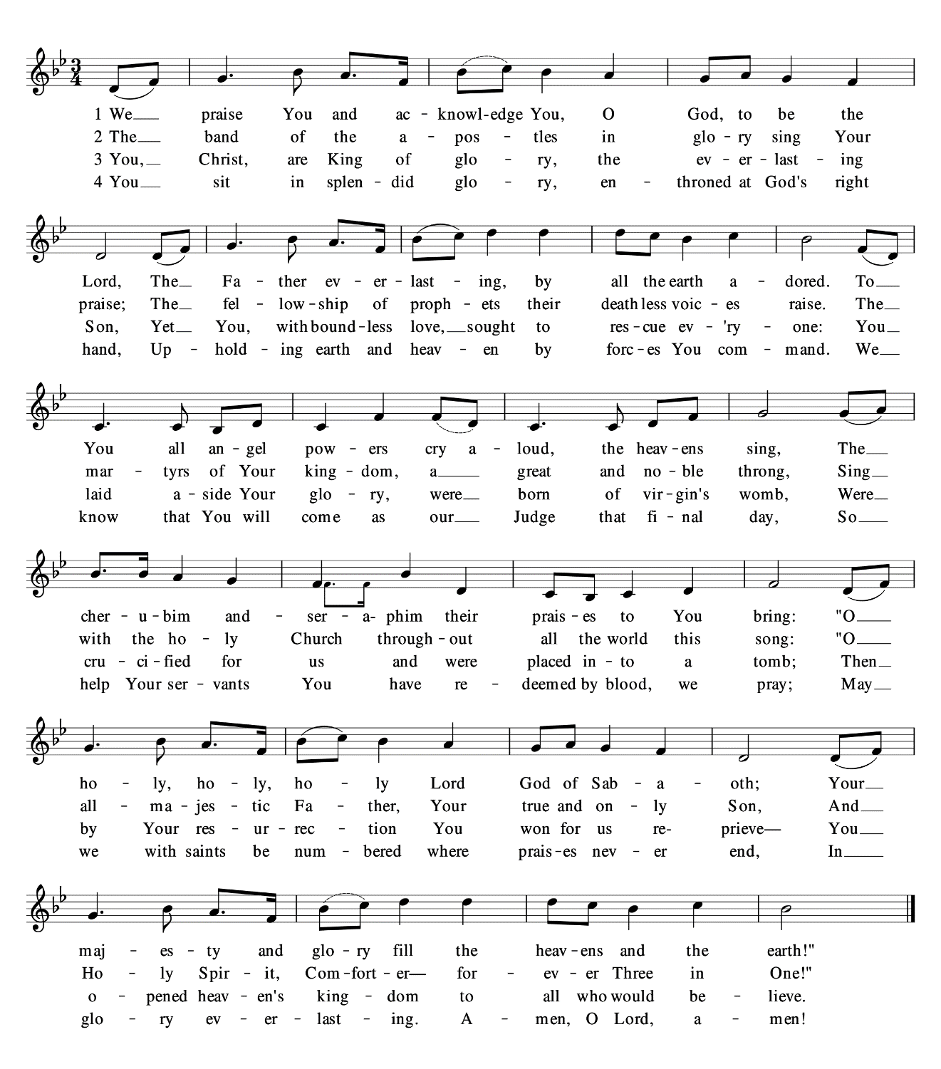
Text: Stephen P. Starke © 1999; admin. Concordia Publishing House. All Rights Reserved, Reprinted under OneLicense.net [enter your church’s license number here]

